**Nigeria country profile**

Published

18 February 2019

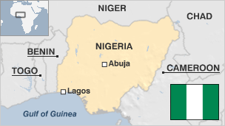

**After lurching from one military coup to another, Nigeria now has an elected leadership.**

But the government faces the growing challenge of preventing Africa's most populous country from breaking apart along ethnic and religious lines.

Thousands of people have died over the past few years in attacks led by jihadists in the north-east.

Separatist aspirations have also been growing, and the imposition of Islamic law in several northern states has embedded divisions and caused thousands of Christians to flee.

Nigeria's insecurity has added to its economic woes, hindering foreign investment.

The former British colony is one of the world's largest oil producers, but few Nigerians, including those in oil-producing areas, have benefited.

* Read more [country profiles](http://news.bbc.co.uk/1/hi/country_profiles/) - Profiles by [BBC Monitoring](http://bbc.co.uk/monitoring)

**President: Muhammadu Buhari**

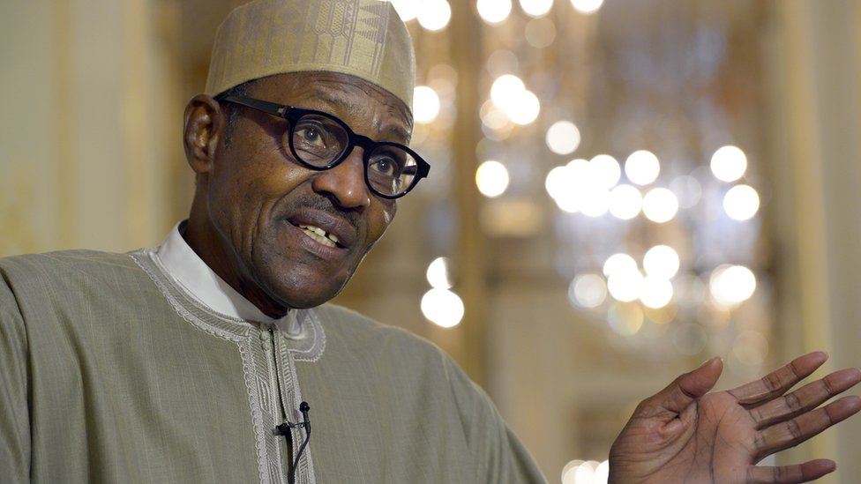image copyrightGetty Images

A former military ruler, Muhammadu Buhari swept to an historic election victory in March 2015 when he became the first opposition candidate to win a Nigerian presidential poll.

After helping oust elected President Shehu Shagari in 1983, the then Major-General Buhari sought to combat crime and corruption, but was also accused of serious rights abuses.

In 1985, he was overthrown by Gen Ibrahim Babangida.

Mr Buhari has now distanced himself from military rule, promising to respect democracy and govern as a civilian leader.

Nigeria is one of Africa's biggest media markets. There are hundreds of radio stations and terrestrial TV networks, as well as cable and satellite platforms.

Reporters Without Borders says journalists face threats and violence in the course of their work.

Many millions of Nigerians are online, and WhatsApp and Facebook are leading social platforms.

**Nigeria profile - Timeline**

Published

18 February 2019

**A chronology of key events:**

**circa 800 BC** - Jos plateau settled by Nok - a neolithic and iron age civilisation.

**circa 11th century onwards** - Formation of city states, kingdoms and empires, including Hausa kingdoms and Borno dynasty in north, Oyo and Benin kingdoms in south.

**1472** - Portuguese navigators reach Nigerian coast.

**16-18th centuries** - Slave trade sees Nigerians forcibly sent to the Americas.

**1809** - Islamic Sokoto caliphate is founded in north.

**1850s** - British establish presence around Lagos.

**1861-1914** - Britain consolidates its hold over what it calls the Colony and Protectorate of Nigeria, governs through local leaders.

**1922** - Part of former German colony Kamerun is added to Nigeria under League of Nations mandate.

**1960** - Independence, with Prime Minister Sir Abubakar Tafawa Balewa leading a coalition government.

**1966 January** - Mr Balewa killed in coup. Maj-Gen Johnson Aguiyi-Ironsi forms military government.

**1966 July** - General Ironsi killed in counter-coup, replaced by Lieutenant-Colonel Yakubu Gowon.

**Biafran war**

**1967** - Three eastern states secede as the Republic of Biafra, sparking three-year civil war.

**1975** - General Gowon overthrown by Brigadier Murtala Ramat Mohammed, who begins process of moving federal capital to Abuja.

**1976** - General Mohammed assassinated in failed coup attempt. Replaced by his deputy, Lt-Gene Olusegun Obasanjo, who helps introduce US-style presidential constitution.

**1979** - Elections bring Alhaji Shehu Shagari to power.

**1983 August-September** - President Shagari re-elected amid accusations of irregularities.

**1983 December** - Maj-Gen Muhammad Buhari seizes power in bloodless coup.

**1985** - Ibrahim Babangida seizes power in bloodless coup, curtails political activity.

**1993 June** - Military annuls elections when preliminary results show victory by Chief Moshood Abiola.

**Abacha years**

**1993 November** - Gen Sani Abacha seizes power, suppresses opposition.

**1994** - Moshood Abiola arrested after proclaiming himself president.

**1995** - Ken Saro-Wiwa, writer and campaigner against oil industry damage to his Ogoni homeland, is executed following a hasty trial. In protest, European Union imposes sanctions until 1998, Commonwealth suspends Nigeria's membership until 1998.

**1998** - Gen Sani Abacha dies and is succeeded by Maj-Gen Abdulsalami Abubakar. Moshood Abiola dies in custody a month later.

**1999** - Parliamentary and presidential elections. Olusegun Obasanjo sworn in as president.

**2000** - Adoption of Islamic Sharia law by several northern states in the face of opposition from Christians. Tension over the issue results in hundreds of deaths in clashes between Christians and Muslims.

**2001** - Tribal war in Benue State, in eastern-central Nigeria, displaces thousands of people. Troops sent to quash the fighting kill more than 200 unarmed civilians, apparently in retaliation for the abduction and murder of 19 soldiers.

**Ethnic violence**

**2002 February** - Some 100 people are killed in Lagos in clashes between Hausas from mainly-Islamic north and Yorubas from predominantly-Christian southwest.

**2002 November** - More than 200 people die in four days of rioting stoked by Muslim fury over the planned Miss World beauty pageant in Kaduna in December. The event is relocated to Britain.

**2003 12 April** - First legislative elections since end of military rule in 1999. Polling marked by delays, allegations of ballot-rigging. President Obasanjo's People's Democratic Party wins parliamentary majority.

**Obasanjo re-elected**

**2003 19 April** - First civilian-run presidential elections since end of military rule. Olusegun Obasanjo elected for second term despite EU observers reporting "serious irregularities".

**2003 September** - Nigeria's first satellite, NigeriaSat-1, launched by Russian rocket.

**2004 May** - State of emergency is declared in the central Plateau State after more than 200 Muslims are killed in Yelwa in attacks by Christian militia; revenge attacks are launched by Muslim youths in Kano.

**Trouble in the south**

**2004 August-September** - Deadly clashes between gangs in oil city of Port Harcourt prompts strong crackdown by troops. Rights group Amnesty International cites death toll of 500, authorities say about 20 died.

**2006 January** onwards - Militants in the Niger Delta attack pipelines and other oil facilities and kidnap foreign oil workers. The rebels demand more control over the region's oil wealth.

**2006 April** - Helped by record oil prices, Nigeria becomes the first African nation to pay off its debt to the Paris Club of rich lenders, which had written off two-thirds of the $30bn debt the previous year.

**2006 August** - Nigeria agrees to cede sovereignty over the disputed Bakassi peninsula to neighbouring Cameroon under the terms of a 2002 International Court of Justice ruling. Transfer takes place in 2008.

**2007 April** - Umaru Yar'Adua of the ruling People's Democratic Party wins the presidential election.

**Boko Haram uprising**

**2009 July** - Hundreds die in northeastern Nigeria after the Boko Haram Islamist movement launches an enduring campaign of violence.

Government frees the leader of the Niger Delta militant group Mend, Henry Okah, after he accepts an amnesty offer.

**2010 May** - President Umaru Yar'Adua dies after a long illness. Vice-President Goodluck Jonathan, already acting in Yar'Adua's stead, succeeds him.

**2011 March** - Vice-President Goodluck Jonathan wins presidential elections.

**2012** January - More than 100 killed in single day of co-ordinated bombings and shootings in Kano, shortly after Boko Haram tells Christians to quit the north.

**2013** May - Government declares state of emergency in three northern states of Yobe, Borno and Adamawa and sends in troops to combat Boko Haram.

**2014** April - Boko Haram kidnaps more than 200 girls from a boarding school in northern town of Chibok, in an incident that draws major national and international outrage.

**2014** November - Boko Haram launches a series of attacks in northeastern Nigeria, capturing several towns near Lake Chad and running raids into neighbouring Chad and Cameroon in early 2015. It switches allegiance from al-Qaeda to the Islamic State group.

**2015** February-March - Nigeria, Chad, Cameroon and Niger form military coalition and push Boko Haram out of all towns back into Sambisa Forest.

**President Buhari elected**

**2015** March - Muhammadu Buhari wins the presidential election, becoming the first opposition candidate to do so in Nigeria's history.

**2016** June - Naira currency floated in attempt to stave off financial crisis caused by low oil prices.

**2016** November - Niger Delta Avengers rebels bomb three oil pipelines in attempt to renew southern insurgency.

**2017** December - Clashes between herders in Benue and Taraba states prompt thousands to flee.

**2018** - Escalating attacks by Boko Haram from August onwards, targeting army bases.

**2019** February - Presidential elections held after last-minute delay of a week.